Cost Allocation Flow Diagram

SAP B1
Source Entity
Target Entity

Cost Allocation Triggers “JE Creations”
JV / NON JV
Post NON JV Category Journal Voucher
Post JV Category Journal Voucher

Post NON JV Category Journal Entry
Post JV Category Journal Entry

Category Types
- JV (JV & Others)
- NON JV (Remaining)
Categories can find in the Company Data UDT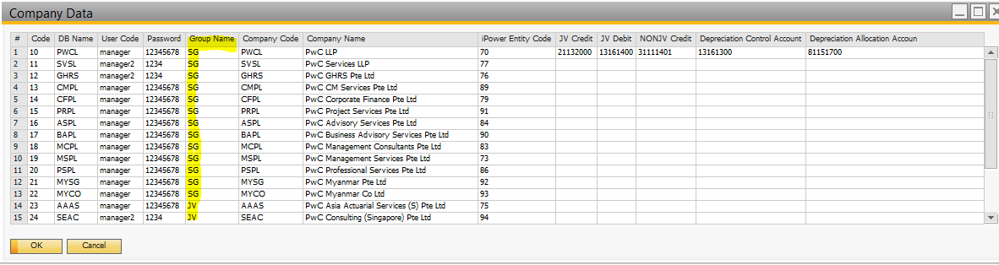

Pre Requisites
- Target entity configuration in cost centres setup
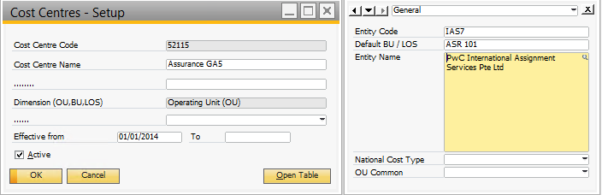
- Target entity configuration in Chart of Accounts
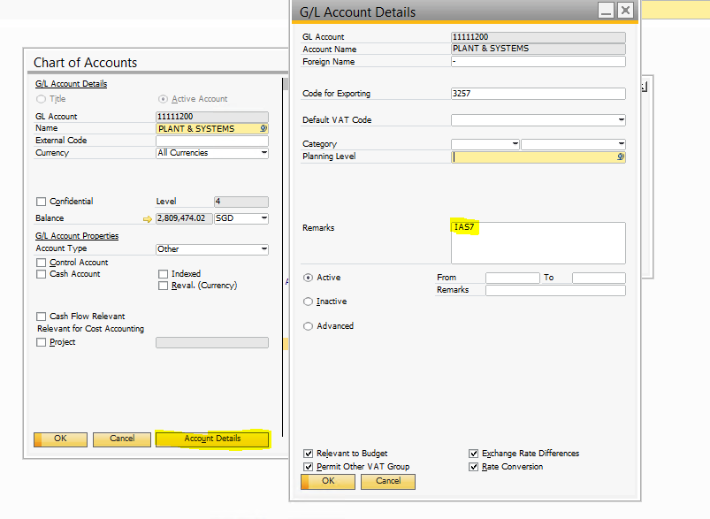
- Company data
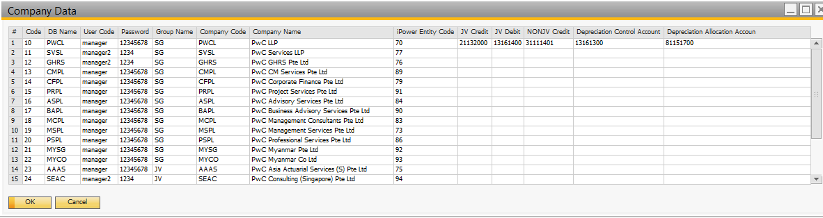
JV Credit: 21132000
JV Debit: 13161400
NONJV Credit: 31111401

Cost Allocation Process
Month : Sep 2016
Distribution : HC1
Cost center : 52115
GL Account : 71101000 – 91101000
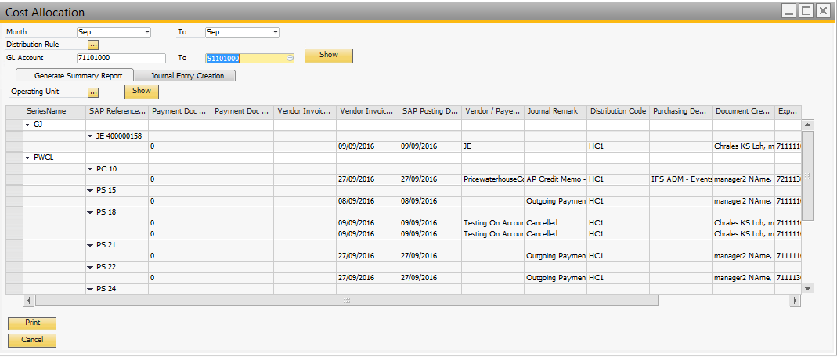
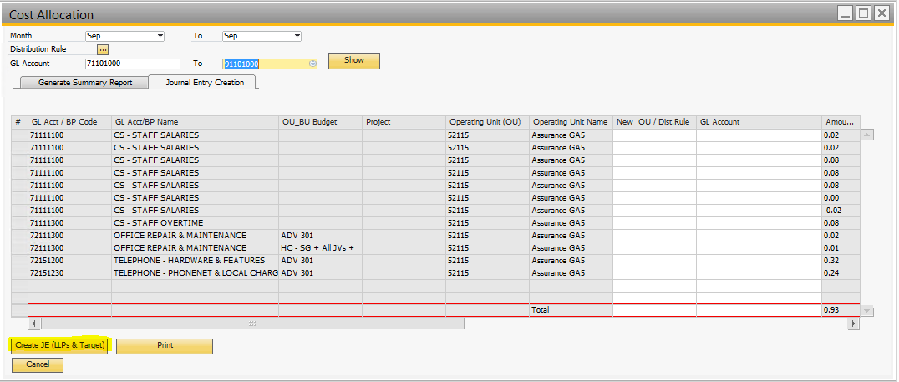
Get the Target Entity:
Look on the Pre requisites “Target entity configuration in cost centres setup”
Target Entity = IAS7
Get the Target GL Code:
Look on the Pre requisites “Target entity configuration in Chart of Accounts”
Target GL Code: 11111200
Get the Category Type:
Ref page 1 “Category Type”
Category Type: NON JV
Create the Journal Entry in Source
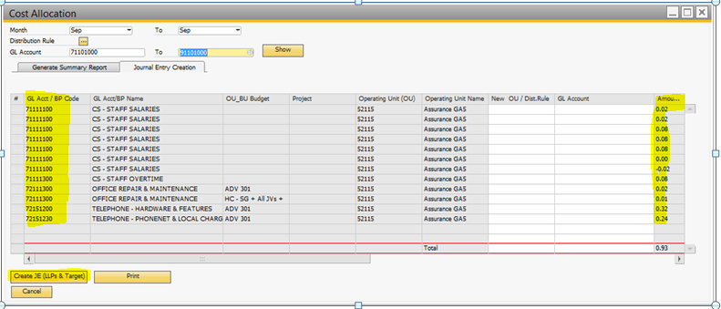
Category Type : NON JV | Category Type : JV
Amount +ve  - Credit = Amount  - GL Code = GL Acct / BP Code + '9999'  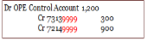  - CostingCode = LOS  - CostingCode2 = BU  - CostingCode3 = OU  Amount -ve  - Debit = Amount  - GL Code = GL Acct / BP Code + '9999'  - CostingCode = LOS  - CostingCode2 = BU  - CostingCode3 = OU  (Debit – Credit) Amount +ve  - Debit = Amount  - GL Code = Target GL Code (11111200)  - CostingCode = LOS  - CostingCode2 = BU  - CostingCode3 = OU  (Debit – Credit) Amount -ve  - Credit = Amount  - GL Code = Target GL Code (11111200)  - CostingCode = LOS  - CostingCode2 = BU  - CostingCode3 = OU | Amount +ve  - Credit = Amount  - GL Code = GL Acct / BP Code + '9999'  - CostingCode = LOS  - CostingCode2 = BU  - CostingCode3 = OU  Amount -ve  - Debit = Amount  - GL Code = GL Acct / BP Code + '9999'  - CostingCode = LOS  - CostingCode2 = BU  - CostingCode3 = OU  (Debit – Credit) Amount +ve  - Debit = Amount  - GL Code = JV Debit: 13161400  - CostingCode = LOS  - CostingCode2 = BU  - CostingCode3 = OU  (Debit – Credit) Amount -ve  - Credit = Amount  - GL Code = JV Debit: 13161400  - CostingCode = LOS  - CostingCode2 = BU  - CostingCode3 = OU

Create the Journal Voucher in Target
Category Type : NON JV | Category Type : JV
Amount +ve  - Credit = Amount  - GL Code = GL Acct / BP Code  - CostingCode = LOS  - CostingCode2 = BU  - CostingCode3 = OU  Amount -ve  - Debit = Amount  - GL Code = GL Acct / BP Code  - CostingCode = LOS  - CostingCode2 = BU  - CostingCode3 = OU  (Debit – Credit) Amount +ve  - Debit = Amount  - GL Code = NONJV Credit: 31111401  - CostingCode = LOS  - CostingCode2 = BU  - CostingCode3 = OU  (Debit – Credit) Amount -ve  - Credit = Amount  - GL Code = NONJV Credit: 31111401  - CostingCode = LOS  - CostingCode2 = BU  - CostingCode3 = OU | Amount +ve  - Credit = Amount  - GL Code = GL Acct / BP Code + '9999'  - CostingCode = LOS  - CostingCode2 = BU  - CostingCode3 = OU  Amount -ve  - Debit = Amount  - GL Code = GL Acct / BP Code + '9999'  - CostingCode = LOS  - CostingCode2 = BU  - CostingCode3 = OU  (Debit – Credit) Amount +ve  - Debit = Amount  - GL Code = JV Debit: 13161400  - CostingCode = LOS  - CostingCode2 = BU  - CostingCode3 = OU  (Debit – Credit) Amount -ve  - Credit = Amount  - GL Code = JV Debit: 13161400  - CostingCode = LOS  - CostingCode2 = BU  - CostingCode3 = OU

